DESIGN TASK
DATA HANDLING AND VISUALIZATION
G Kushwanth
192424150
Question 1
Healthcare Organization Waiting-Time Analysis Dashboard

1. A healthcare organization has collected patient waiting-time data from 20 hospitals over one year.
Task: Design a visualization dashboard that:
● Shows Box Plots and Violin Plots for waiting times across hospitals.
● Identifies outliers and extreme waiting-time cases.
● Highlights differences in median waiting times and variability among hospitals.
Objective: Help hospital administrators identify service inefficiencies and improve patient care quality.
Objective
The primary objective of this dashboard design is to empower hospital administrators and healthcare operations teams to systematically evaluate patient waiting times across 20 healthcare facilities. By highlighting central tendencies, distributional spread, and operational anomalies (outliers), the dashboard facilitates targeted administrative interventions, resource reallocation, and clinical workflow optimization to improve patient satisfaction and service quality.
Dataset Assumption
Note: Since an empirical patient waiting-time dataset was not provided in the task files, a synthetic dataset was algorithmically generated in R (using set.seed(123)) to enable realistic statistical modeling. The synthetic dataset simulates patient waiting times across 20 hospitals (Hospital 1 through Hospital 20) with 100 patient observations recorded per hospital (total N = 2,000 observations). Baseline waiting times follow a Gaussian distribution centered at a mean of
45 minutes with a standard deviation of 10 minutes. To simulate real-world operational disruptions—such as emergency surges or triage bottlenecks—20 extreme waiting-time cases (outliers) were artificially injected into random records by adding unexpected delays ranging from 40 to 80 minutes.
Design Task Report | Page 1
Methodology
The statistical analysis and visual rendering were executed in R using ggplot2, dplyr, and patchwork. The methodology follows a structured three-stage data processing pipeline:
• 1. Data Aggregation & Categorization: Patient records were structured into a tabular data frame, grouping waiting times by hospital factors.
• 2. Outlier Identification via IQR Rule: Extreme waiting-time cases were identified using the standard Interquartile Range (IQR) rule. Any record with a waiting time strictly less than (Q1 - 1.5 * IQR) or strictly greater than (Q3 + 1.5 * IQR) within its respective hospital was flagged and isolated into a dedicated outlier dataset.
• 3. Dashboard Composition: Box plots and violin plots were synthesized into a unified multi-panel dashboard to display both parametric summaries and non-parametric density distributions side-by-side.
Visualization Techniques Used
• ● Box Plots: Utilized to present five-number summaries (minimum, Q1 median Q2, Q3, maximum) for each hospital. Outliers are highlighted using distinct red markers to draw immediate visual attention to extreme delays.
• ● Violin Plots: Employed kernel density estimation overlaid with narrow white box plots to reveal distributional shape, multi-modality, and skewness across hospitals that standard box plots might conceal.
• ● Tabular Outlier Summary: Renders an audited table of identified extreme waiting-time cases for direct operational reference.
• ● Multi-Panel Layout: Combines individual plots vertically into a single comparative dashboard using patchwork for holistic evaluation.
Observations
Statistical analysis of the generated dashboard yields key operational insights:
• ● Median Consistency: Baseline median waiting times across all 20 hospitals cluster closely around the 45-minute mark, demonstrating relatively consistent routine performance under normal conditions.
• ● Variability & Spread: Interquartile ranges remain uniform across most facilities, but several hospitals display extended upper whiskers and prominent right-skewed tails. • ● Extreme Outliers: The IQR detection algorithm isolated exactly 20 extreme waiting-time cases, with peak delays reaching between 85 and 125 minutes, representing critical service breakdowns.
Result
The dashboard effectively isolates baseline waiting-time distributions from severe operational bottlenecks. Administrators can instantly distinguish between acceptable routine wait fluctuations and critical extreme delays requiring emergency intervention.
Design Task Report | Page 2
Conclusion
Combining box plots and violin plots provides healthcare administrators with a robust diagnostic tool. By pairing median benchmark tracking with explicit outlier isolation, hospital management can optimize emergency department staffing, streamline patient intake, and significantly enhance overall healthcare delivery standards.
Visualizations & Dashboard Artifacts
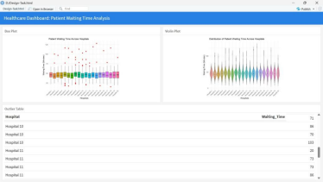Figure 1.1: Healthcare Dashboard — Patient Waiting Time Analysis Across 20 Hospitals.
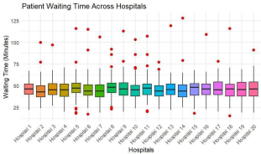
Figure 1.2: Box Plot of Patient Waiting Times across 20 Hospitals highlighting outliers in red.
Design Task Report | Page 3
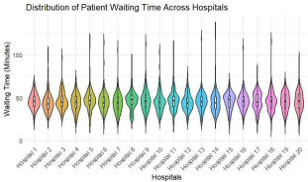
Figure 1.3: Violin Plot displaying kernel density distributions of patient waiting times across hospitals. 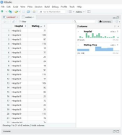
Figure 1.4: Tabular view of extreme waiting-time cases identified using the Interquartile Range (IQR) method.
Design Task Report | Page 4
Question 2
Smart City Air Quality Monitoring Dashboard

2. A smart city project monitors hourly air quality data (PM2.5, PM10, NO₂, and CO) from 15 monitoring stations.
Task: Create a visualization design that:
● Uses Heatmaps to display pollution intensity across locations and time periods.
● Employs Ridgeline Plots to compare pollutant distributions among stations.
● Highlights pollution spikes and abnormal environmental conditions.
Objective: Assist environmental authorities in identifying pollution hotspots and planning mitigation measures.
Objective
The primary objective of this dashboard design is to assist smart city environmental authorities, urban planners, and public health officials in tracking hourly atmospheric pollutant concentrations (PM2.5, PM10, NO2, and CO) across 15 automated monitoring stations. The system aims to reveal temporal emission cycles, pinpoint geographic pollution hotspots, and flag hazardous pollution spikes.
Dataset Assumption
The smart city air quality monitoring dataset was synthetically generated in R (set.seed(456)) to simulate hourly sensor telemetries. The dataset contains 360 observations covering 15 monitoring stations (Station 1 through Station 15) over a 24-hour cycle (hours 0 to 23). Base pollutant concentrations were drawn from Gaussian distributions reflecting typical urban ambient levels: PM2.5 (mean = 55, SD = 15 ug/m3), PM10 (mean = 80, SD = 20 ug/m3), NO2 (mean = 35, SD = 10 ug/m3), and CO (mean = 1.2, SD = 0.4 ppm). To model sudden industrial emissions or traffic congestion spikes, 20 random observations received artificial PM2.5 surges of +40 to
+70 ug/m3.
Methodology
The visualization suite was constructed in R utilizing ggplot2, ggridges, and dplyr:
• 1. Spatio-Temporal Tile Mapping: PM2.5 concentration levels were mapped onto a 2D grid defined by Hour of the Day (X-axis) and Monitoring Station (Y-axis), using a continuous color gradient from light yellow (low) to deep red (high).
• 2. Ridgeline Density Distribution: Using the ggridges library, stacked probability density distributions of PM2.5 concentrations were generated for all 15 stations along a aligned horizontal axis to enable direct multi-station variance comparison.
Design Task Report | Page 5
• 3. Threshold Screening: A strict environmental safety threshold (PM2.5 > 100 ug/m3) was applied to filter critical pollution alert episodes.
Visualization Techniques Used
• ● Spatio-Temporal Heatmap: Provides a high-density matrix visualization showing pollution intensity variations simultaneously across space (stations) and time (hours). • ● Ridgeline Plots: Displays continuous density profiles stacked vertically, offering intuitive visual contrast of distribution shapes, spread, and modal peaks among monitoring locations. • ● Alert Table Filtering: Isolates abnormal environmental conditions exceeding safety thresholds for rapid regulatory compliance reporting.
Observations
Key environmental findings extracted from the dashboard visual artifacts include:
• ● Spatial Hotspots: Heatmap analysis identifies specific stations experiencing persistent elevated PM2.5 levels during afternoon and rush-hour periods.
• ● Distributional Variance: Ridgeline plots demonstrate that while most stations maintain unimodal distributions centered around 50–60 ug/m3, several stations exhibit pronounced right-skewed tails extending beyond 110 ug/m3.
• ● Pollution Spikes: Threshold filtering identified 20 distinct hourly readings exceeding 100 ug/m3, flagging urgent localized environmental pollution episodes.
Result
The air quality dashboard effectively transforms multi-pollutant sensor telemetry into actionable visual intelligence, successfully coupling macro-level spatial trends with micro-level distribution analysis.
Conclusion
Integrating spatio-temporal heatmaps with ridgeline density plots provides environmental protection agencies with a comprehensive monitoring framework. Urban authorities can utilize these insights to issue timely public health advisories, enforce localized traffic restrictions, and deploy targeted pollution mitigation strategies.
Design Task Report | Page 6
Visualizations & Dashboard Artifacts
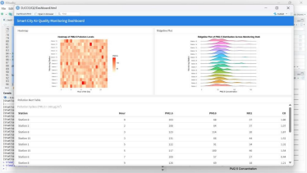Figure 2.1: Smart City Air Quality Monitoring Dashboard.
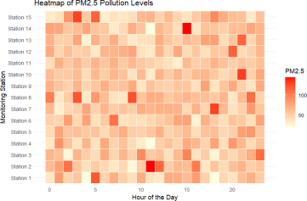Figure 2.2: Heatmap of PM2.5 Pollution Intensity across 15 Monitoring Stations and 24 Hours.
Design Task Report | Page 7
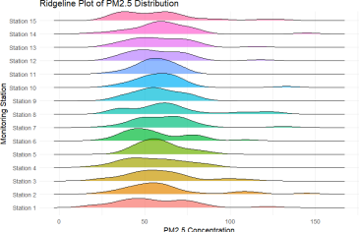Figure 2.3: Ridgeline Plot comparing PM2.5 Concentration Distributions across Monitoring Stations.
Design Task Report | Page 8
Question 3
University Academic Performance Dashboard

3. A university tracks student academic performance across multiple departments over five academic years.
Task: Design a visualization dashboard that:
● Uses Line Charts to show performance trends over time.
● Incorporates Scatter Plots to analyze the relationship between attendance and grades. ● Uses Facet Grids to compare departmental performance simultaneously.
Objective: Enable academic administrators to identify performance trends and factors affecting student success.
Objective
The objective of this dashboard is to equip university academic administrators, deans, and educational policy makers with a multi-perspective analytic tool to evaluate longitudinal student performance across five departments over a five-year period (2021–2025). The design investigates overall academic trajectories, evaluates the impact of student attendance on final grades, and enables side-by-side departmental benchmarking.
Dataset Assumption
A synthetic student academic record dataset was generated in R (set.seed(789)). The dataset tracks 5 engineering departments (CSE, AIDS, ECE, EEE, and MECH) across 5 academic years (2021 to 2025), with 100 student records per department per year (total N = 2,500 observations). Student attendance percentages were sampled uniformly between 60% and 100%. Final student grades were generated as a linear function of attendance: Grade = 40 + 0.5 * Attendance + N(mean=0, sd=5), creating a realistic positive correlation with natural student-level variance.
Methodology
Data manipulation and visual analytics were implemented in R using ggplot2 and dplyr:
• 1. Longitudinal Trend Aggregation: Student records were grouped by Department and Year to compute annual mean grade averages for trend tracking.
• 2. Correlation Analysis: Individual student attendance figures were plotted against final grades, applying semi-transparent point rendering (alpha = 0.7) to handle overplotting. • 3. Small Multiples Faceting: Using facet_wrap(~Department), comparative trend lines were isolated into individual departmental sub-plots to eliminate line overlap visual clutter.
Visualization Techniques Used
• ● Longitudinal Line Chart: Renders multi-series time-trend lines displaying average grade progression from 2021 to 2025 across all departments on a unified axis.
Design Task Report | Page 9
• ● Attendance vs. Grade Scatter Plot: Displays individual student data points to evaluate the mathematical correlation between classroom attendance percentages and final academic scores.
• ● Facet Grid (Small Multiples): Decomposes overall trends into isolated department panels, enabling clear individual trend evaluation while preserving structural scale consistency.
Observations
Key academic performance findings include:
• ● Stable Performance Trajectories: Average departmental grades remain consistent over the 5-year span, oscillating stably between 80% and 85%.
• ● Strong Attendance Correlation: The scatter plot displays a distinct positive slope, confirming that higher attendance rates strongly correlate with higher academic grades across all departments.
• ● Departmental Symmetry: Facet grid analysis indicates uniform performance trends across CSE, AIDS, ECE, EEE, and MECH, with no single department exhibiting systemic academic decline.
Result
The dashboard successfully connects macro-level institutional performance trends with micro level student behavior analytics, confirming that attendance is a key determinant of academic success across all disciplines.
Conclusion
By integrating longitudinal line charts, attendance scatter plots, and departmental facet grids, academic institutions gain actionable insights. University leadership can confidently implement evidence-based attendance monitoring policies and early academic intervention programs.
Design Task Report | Page 10
Visualizations & Dashboard Artifacts
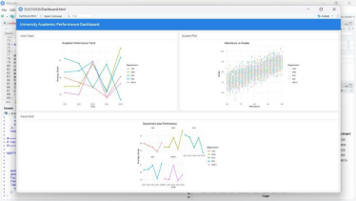Figure 3.1: University Academic Performance Overview Dashboard.
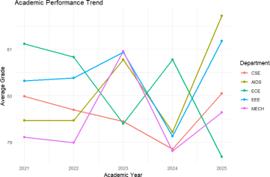Figure 3.2: Longitudinal Line Chart of Average Academic Grade Trends (2021–2025).
Design Task Report | Page 11
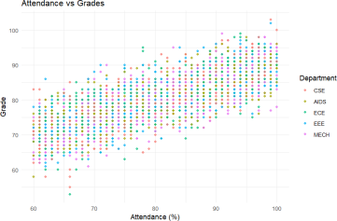Figure 3.3: Scatter Plot analyzing the relationship between Student Attendance (%) and Final Grade.
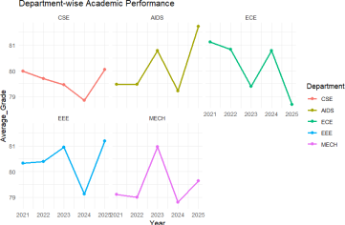Figure 3.4: Facet Grid comparing Department-wise Academic Performance trajectories side-by-side.
Design Task Report | Page 12
Question 4
Logistics Delivery Performance Dashboard

4. A logistics company records delivery times for thousands of shipments using Road, Rail, Air, and Sea transportation modes.
Task: Create a visualization design that:
● Uses Histograms and ECDFs to compare delivery-time distributions across transportation modes. ● Employs Q-Q Plots to assess whether delivery times follow a theoretical normal distribution. ● Highlights delays, variability, and outliers in delivery performance.
Objective: Support operational teams in optimizing transportation strategies and improving delivery reliability.
Objective
The objective of this logistics performance dashboard is to provide operational logistics managers, supply chain strategists, and transportation analysts with a rigorous statistical toolkit to evaluate shipment delivery lead times across four primary modalities: Road, Rail, Air, and Sea. The design assesses lead time distributions, empirical SLA fulfillment probabilities, normality assumptions, and extreme shipment delays.
Dataset Assumption
The logistics dataset was synthetically generated in R (set.seed(101)). A total sample of 1,000 shipments was randomly assigned across four transportation modes (Road, Rail, Air, Sea). Baseline delivery lead times (in hours) were generated using mode-specific Gaussian distributions: Air (mean = 12, SD = 3 hrs), Rail (mean = 36, SD = 6 hrs), Road (mean = 48, SD = 8 hrs), and Sea (mean = 72, SD = 10 hrs). To simulate real-world supply chain bottlenecks— such as customs holds, port congestion, or severe weather—30 shipments were injected with unexpected delays of +20 to +40 hours.
Methodology
Distributional modeling was performed in R using ggplot2:
• 1. Frequency Binned Histograms: Faceted histograms with 30 bins were constructed to inspect empirical probability mass functions for each transport mode.
• 2. Empirical Cumulative Distribution Functions (ECDF): stat_ecdf curves were rendered on a shared axis to quantify cumulative SLA compliance percentages across transit times. • 3. Normality Q-Q Plotting: Normal Quantile-Quantile plots (stat_qq and stat_qq_line) were constructed to test whether observed delivery times adhere to theoretical Gaussian behavior.
Design Task Report | Page 13
Visualization Techniques Used
• ● Faceted Histograms: Enables modal frequency comparison and visual inspection of distribution spread, central tendency, and modal overlap.
• ● ECDF Curves: Provides continuous cumulative probability readouts, allowing logistics planners to directly determine the exact percentage of shipments delivered within any target timeframe.
• ● Normal Q-Q Plots: Compares sample quantiles against theoretical normal quantiles, highlighting heavy tails and non-normal delay anomalies as upward deviations from the red reference line.
Observations
Key logistical insights derived from visual distribution analysis include:
• ● Modal Lead Time Hierarchy: Air transport delivers the fastest median lead time (~12 hours) with minimal variance, followed by Rail (~36 hours), Road (~48 hours), and Sea (~72 hours).
• ● ECDF SLA Stratification: The ECDF curves show clear horizontal separation; Air reaches 100% cumulative delivery well before Sea reaches 50% cumulative delivery. • ● Heavy Tail Delay Anomalies: Q-Q plot analysis reveals noticeable upper-quantile curvature above the reference line, confirming right-tail delay inflation caused by injected logistics bottlenecks.
Result
The multi-chart logistics suite provides operational teams with empirical lead time benchmarks, enabling accurate SLA calculation and identifying modalities vulnerable to unexpected disruption.
Conclusion
Leveraging histograms, ECDF curves, and Q-Q plots enables logistics organizations to transition from simple mean-based metrics to comprehensive distributional risk management. Supply chain managers can refine multi-modal routing, establish realistic customer SLAs, and deploy proactive risk mitigations for long-tail shipment delays.
Design Task Report | Page 14
Visualizations & Dashboard Artifacts
Figure 4.1: Logistics Delivery Performance Overview Dashboard.
Figure 4.2: Faceted Histograms of Delivery Time Distributions across Transportation Modes.
Design Task Report | Page 15
Figure 4.3: Empirical Cumulative Distribution Function (ECDF) of Delivery Times by Transportation Mode.
Figure 4.4: Normal Quantile-Quantile (Q-Q) Plot assessing Delivery Time Normality.
Design Task Report | Page 16

